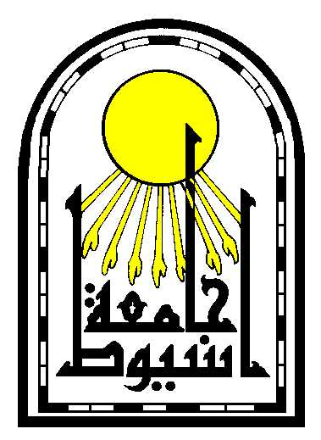
South Egypt Cancer Institute (SECI)

Certificate of Employment

1 – Surname : El Barody
2 – First Name: Mohamed
3 – Middle Name: Moamin
4 – Sex : Male
5 – Date of Birth: 12/10/1981
6 – Place and country of birth: Sohag Gerga
7 – Nationality: Egyptian.
8 – Place of Occupation: Oncology radiology department, South Egypt Cancer Institute – Assiut University – Egypt.
9 – Current Occupation: Assistant lecturer of radiodiagnosis - South Egypt Cancer Institute.

